**\*1st\*** - the connection will not success without making connection setup by putting the port on credit card integration screen

if you didn't make this step the integration will not work

**\*2nd\*** on OPD visit screen if you select multi-pay and try to send the amount it will give the total amount on the POS machine (example you selected cash 40 SAR , span 40 SAR , after sending the POS will receive 80 SAR

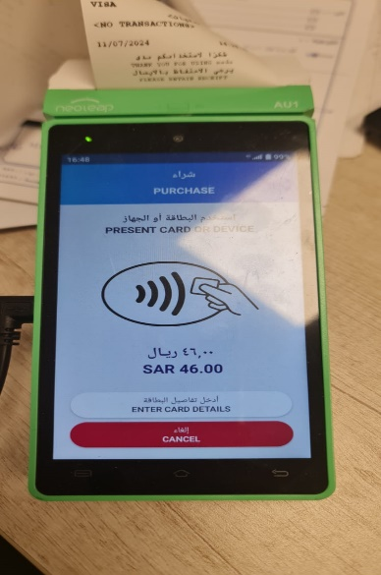

After making the POS payment process when you select Ok to complete the invoice it giving error

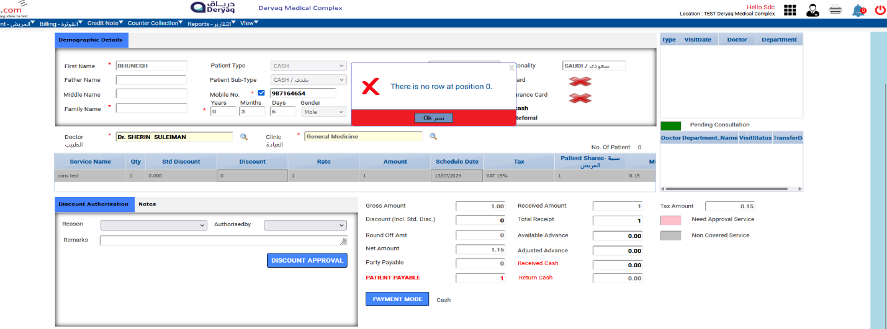

**3rd** the integration wasn’t working on Doctor Request or External services request.